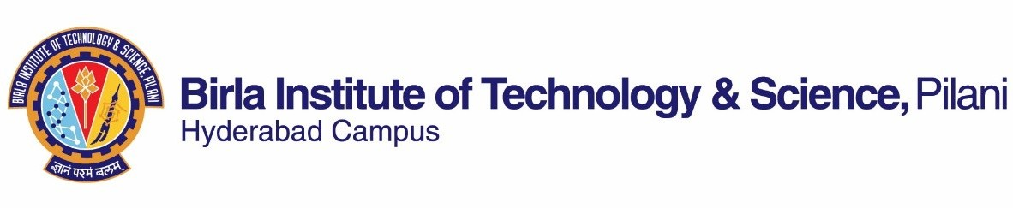

# SECOND SEMESTER 2022-2023

Course Handout Part II

Date: 16-01-2023

In addition to part-I (General Handout for all courses appended to the time table) this portion gives further specific details regarding the course.

**Course No. :** MATH F342

**Course Title :** Differential Geometry

**Instructor-in-Charge :** Sushil Bhunia

Name of the Tutors : Sayantan Ghosh and Sunil Rampuria.

**Scope and Objective of the Course:** The objective of this course is to provide a systematic exposition of the essential concepts of modern differential geometry, and an understanding and appreciation for the intrinsic beauty of these concepts, as well as their deep relationships to physical Sciences. The under current is to generalize and reinforce the classical subject in a modern way.

# Textbooks:

1. Andrew Pressley– Elementary Differential Geometry, 2nd Edition (Corrected Print), Springer (2012).

# Reference books

1. D. Somasundaram, Differential Geometry A First Course, Narosa Publishing House, First Edition, 2012.
2. Gray A, Abbena E, Salamon S – Modern differential geometry of curves and surfaces with MATHEMATICA, 3rd Edition, CRC Press (2006).
3. Oprea, J – Differential Geometry and Its Applications, Mathematical Association of America(2007).

# Course Plan:

|  |  |  |  |
| --- | --- | --- | --- |
| **Lecture No.** | **Learning objectives** | **Topics to be covered** | **Chapter in the Text Book** |
| 1-4 | Local and  global theory of curves. | Parameterized curves, reparameterization, arc length, level curves vs parameterized curves. | 1.1-1.4 |
| 5-8 | Curvature of regular plane and space curves. | 2.1-2.3 |
| 9-11 | Simple closed curves in the plane, the isoperimetric inequality, the four vertex theorem. | 3.1-3.3 |
| 12-16 | To understand basic concepts regarding surface in 3 dimensional space, examples of surfaces. | Concepts of a surface, smoothness, tangent space and normal vector, orientability, examples of surfaces. | 4.1-4.4 |
| 17-20 | Measurements along surfaces, geometric invariance under bending.  Various ways of determining how fast the surface curves (curvatures). | The first fundamental forms, isometries of surfaces, conformal mappings of surfaces, surface area. | 5.1-5.4 |
| 21-25 | The second fundamental form, the curvature of curves on a surface, normal and principal curvatures, geometric interpretation of principal curvatures. | 6.1-6.4 |

|  |  |  |  |
| --- | --- | --- | --- |
| 26-30 | How one determines the curvature? | Gaussian and mean curvatures, surfaces of constant Gaussian curvature and their classification and examples, the Gauss map. | 7.1 and 7.3-7.6 |
| 31-34 | Shortest paths between two points of a surface. | Definition and basic properties of geodesic, geodesic equations, behavior under isometry, geodesics on surfaces of revolution, shortest  paths. | 8.1-8.5 |
| 35-38 | Gaussian curvature is preserved under bending, existence and uniqueness of surfaces with given 1st and 2nd fundamental forms.  Gauss-Bonnet Theorem relates the Euler characteristic (a topological invariant) with the curvature (a geometric invariant) of the surface. | Gauss’s remarkable theorem, isometries of surfaces and The Coddazzi- Mainardi equations. | 10.1-10.3 |
| 39-40 | The Gauss-Bonnet Theorem for compact surfaces. | 11.3 |

**Evaluation Scheme:**

|  |  |  |  |  |
| --- | --- | --- | --- | --- |
| **Component** | **Duration** | **Weightage (%)** | **Date & Time** | **Nature of Component** |
| Quiz | 50 minutes | 15 | TBA | Open Book |
| Mid-sem | 90 minutes | 25 | **16/03/2023 (4-5:30 PM)** | Closed Book |
| Assignment |  | 15 | TBA | Take Home |
| Comprehensive Exam | 3 hours | 45 | **16/05/2023 (AN)** | Closed Book |

* **Chamber consultation hour:** To be announced in the class.
* **Total Marks: 100**
* **Notices:** The notices concerning this course will be displayed on the CMS Notice Board only.
* **Make-up Policy:** Make-up will be given only for very genuine cases and prior permission has to be obtained from the I/C.
* **Academic Honesty and Integrity Policy:** Academic honesty and integrity are to be maintained by all the students throughout the semester and no type of academic dishonesty is acceptable.

**INSTRUCTOR-IN-CHARGE**

**MATH F342**